

Clinical Guideline/Procedural document for:
“Cardiac Physiologist/Scientist-Led Transoesophageal Echocardiography (TOE)”

SUMMARY
This procedural document outlines the protocol for Cardiac Physiologists and Cardiac Clinical Scientists performing all aspects of TOE.

PUBLICATION DETAILS

Author of Clinical Guideline | Vitor Morgado Weaver, Chief Cardiac Physiologist  Dr. Andrew Ludman, Consultant Cardiologist
Division/ Department responsible for Clinical Guideline | Cardiology/Medicine
Contact details | 3995
Version number | 1.0
Replaces version number | New guideline
Date written | 01/05/ 22
Consultation undertaken with: | Dr. Andrew Ludman
Approving body and date approved | Cardiology Governance Group
Review date | 01/01/2025 (3-6 months prior to expiry date)
Expiry date | 30/ 05/25
Date document becomes live | 25th May 2022

CONTENTS

1. INTRODUCTION 3
2. PERSONAL QUALIFICATIONS 3
3. TRAINING 3
4. CLINICAL SUPERVISION 4
5. INFORMED CONSENT 5
6. PATIENT SELECTION (INCLUSION & EXCLUSION) 5
7. PROTOCOL 5
8. COMPLICATIONS AND EMERGENCY PROTOCOLS 7
9. SERVICE EVALUATION 8
10. ASSOCIATED TRUST POLICIES/DOCUMENTS 8
11. REFERENCES 8
12. APPENDIXES 9

1. INTRODUCTION
  - Transoesophageal echocardiography (TOE) is an important cardiovascular imaging modality. Its proximity with the heart and great vessels allows for excellent windows and detailed assessment. It offers more accurate information than transthoracic echocardiography for some patients with particular diagnoses (e.g. valve endocarditis), those undergoing invasive cardiac interventions or where other imaging techniques were suboptimal or contra-indicated.
1.2 Training a Cardiac Physiologist/Scientist in TOE intubation will provide opportunities to expand the existing TOE service. The Physiologist/Scientist will be able to provide support to consultant cardiologists, and deliver a TOE service on days where it is usually not available due to low staffing levels. It will enable shorter waiting times, thereby providing faster diagnoses and optimal patient treatment.
1.3 The procedure involves applying local anaesthetic spray to the back of the patient’s throat, and then passing the probe into the oesophagus (intubation), whilst asking the patient to swallow. Once in place, the probe is manoeuvred to take multiple images of the heart, according to the British Society of Echocardiography (BSE) and the European Association for Cardiovascular Imaging (EACVI) recommendations, but taking into consideration the patient tolerance to the probe and stable vitals. In cases where intubation is difficult, intravenous conscious sedation is sometimes required, and this is administered by a nurse or Consultant.

2. PERSONAL QUALIFICATIONS
2.1 The Cardiac Physiologist/Scientist performing intubation must be BSE accredited in TTE and have extensive experience in all aspects in echocardiography, both TTE and TOE. It should also be able to use/analyse 3D-echo when appropriate.
2.2 A Clinical Scientist is a registered Health and Care Professions Council (HCPC) professional who has undergone a Master’s degree level training programme, or who has achieved equivalence through the Scientist Training Programme (STP) provided by the Academy of Healthcare Sciences (AHCS).
2.3 They must have up-to-date immediate life support (ILS) or advanced life support (ALS) training. Anaphylaxis training must be up-to-date.

3. TRAINING
3.1 The Physiologist/Scientist should have extensive experience in all aspects of echocardiography, including TOE and should have BSE TTE Accreditation or equivalent (EACVI). They are also expected to pursue BSE/EACVI TOE Accreditation.
3.2 The initial training must include over 12 months of experience performing TOE on patients who are already intubated. This should include a variety of settings:
- Outpatient/Elective procedures
- Inpatients
- Intensive Care Unit
- Theatre/Catheterisation Lab (if under general anaesthetic – GA)
3.3 To obtain BSE TOE Accreditation, the Physiologist/Scientist will have to successfully pass a theory exam, perform/report 75 scans (BSE Accreditation or equivalent – EACVI) and pass a VIVA examination on a simulator, where practical skills are tested. For full details, refer to the accreditation pack available from the BSE website (https://www.bsecho.org/).
3.4 Intubation is not covered as part of the BSE TOE Accreditation. This will be taught by Consultant Cardiologists during TOE sessions.
3.5 External/eLearning training on oesophageal intubation is encouraged.
3.6 The Physiologist/Scientist has had over 12 months observing intubation performed under local and general anaesthesia.
3.7 Hands-on training will be provided during TOE sessions by the Consultant Cardiologists.
3.8 The American Society of Echocardiography (ASE) guidance suggests a minimum of 25 successful intubations to be performed by the trainee until deemed competent. A log of the successful intubations should be kept by the trainee and co-signed by the supervisor (see appendix 2)
3.9 To remain BSE TOE Accredited, the Physiologist/Scientist must follow BSE guidance regarding Re-Accreditation after 5 years of obtaining this certification. There is no specified number of intubations per year to maintain Accreditation.
3.10 Similar requirements are needed to obtain EACVI accreditation in TOE (https://www.escardio.org/Education/Career-Development/Certification/Adult-Transoesophageal-Echo)

4. CLINICAL SUPERVISION
4.1 The Cardiac Physiologist/Scientist will be under direct supervision of a Consultant Cardiologist throughout the training period (see competency document) and until the trainee is able to safely and consistently intubate.
4.2 Once competency for oesophageal intubation has been achieved, a Consultant Cardiologist must still be available to support or intervene, in case issues arise.
4.3 The main supervisor is Consultant Cardiologist Dr Andrew Ludman, who is the Clinical Lead for Echocardiography in the department.

5. INFORMED CONSENT
5.1 Informed consent is usually obtained by a Cardiology Consultant or Registrar. This should include:
- Confirmation of correct demographics
- Name of the procedure – Transoesophageal Echocardiogram;
- Intended benefits/purpose – to assess heart valves, structure/function of the heart;
- Associated risks – minor bleeding and/or throat discomfort post-procedure, low risk of aspiration, infection and less than 1 : 5-10 000 risk of oesophageal damage that may require treatment.
5.2 It may also be obtained by an experienced Physiologist/Scientist with extensive clinical experience in TOE and training in informed consent.
5.3 Informed consent training may be obtained by shadowing Consultants and Registrars and only the Physiologists/Scientists competent to fully perform TOE should be able to consent patients for the procedure.
5.4 All Physiologists/Scientists involved in TOE consent must be aware of the Trust policy for Consent for Examination or Treatment (see HUB) and complete some form of informed consent training (in-house or external).
5.5 It is encouraged that Physiologists/Scientists complete the Good Clinical Practice (GCP) eLearning module available on the National Institute for Health and Care Research (NIHR) website (available from https://www.nihr.ac.uk/health-and-care-professionals/learning-and-support/good-clinical-practice.htm).

6. PATIENT SELECTION (INCLUSION & EXCLUSION)
6.1 All patients should be assessed on a case-by-case basis by the Consultant in charge of their care. Any issues/concerns should be addressed prior to the procedure.
6.2 Patients excluded from Physiologist/Scientist intubation are those who have contra-indications for TOE (as below), and those who are known to be difficult to intubate.
Absolute contra-indications | Relative contra-indications
Oesophageal stricture | Oesophageal/gastric varices
Trachea-oesophageal fistula | Barret’s oesophagus
Oesophageal trauma | Zencker’s diverticulum
Oesophageal surgery/esophagectomy | Oesophageal carcinoma
Perforated viscus | Previous thoracic radiotherapy
 | Mallory-Weiss tear
 | Colonic interposition
 | Previous bariatric surgery
 | Dysphagia
 | Coagulopathy/bleeding disorder
 | Atlanto-axial joint disease limiting cervical mobility
 | Severe cervical osteoarthritis
 | Thoracic aortic aneurysm

7. PROTOCOL
7.1 Procedure checks to confirm the patient’s identity and potential contra-indications are performed during time-out. The WHO TOE checklist may be used as guidance (appendix 1), but local time-out processes are to be followed. If procedural consent has not been obtained prior to bringing the patient into the procedure room, this should be done at this stage.
7.2 Monitoring equipment is attached to the patient. This should include electrocardiographic, heart rate, blood pressure and oxygen saturation monitoring. Suction should be available. This is usually the responsibility of the nurses assisting the procedure.
7.3 If sedation is used, place a nasal cannulae on the patient with a flow of 2 L/min. Oxygen saturation should be continuously monitored by the team.
7.4 Midazolam is the usual choice for sedation in the department and this is administered by a nurse or Consultant in slow increments to prevent deep sedation. Particular attention should be taken in patients with respiratory diseases (i.e. COPD) and older patients.
7.5 The reversal agent, Flumazenil, should be at hand to use if needed. Usual initial dose is 200 mcg IV over 15 seconds, followed by further doses of 100 mcg at 60 sec intervals. Typical dose range 300-600 mcg with a maximum dose of 1 mg. Flumazenil has a short duration of action and therefore, re-sedation may occur at a later stage. Therefore, post procedure monitoring should be performed.
7.6 Local sedation (Xylocaine 2% spray) may be administered by the Physiologist/Scientist under the Xylocaine protocol (P class medicine) or the Consultant Cardiologist. The spray is applied to the back of the patient’s throat, up to a maximum of 20 sprays, however that is dependent on the operator/Consultant. The patient is then asked to /gargle and swallow the spray.
7.7 The patient is positioned in left lateral decubitus and sedation is given. Usually a nurse, Registrar or Consultant will administer this. A mouth guard is then placed for patient and probe safety. Suction may be required at this stage and the patient’s vitals continuously monitored.
7.8 The lubrication gel is applied to the prepared TOE probe (as per Trust guidance).
7.9 Intubation is attempted by placing the probe to the back of the pharynx, and then asking the patient to swallow – to advance the probe at this stage, apply gentle pressure forwards.
7.10 If intubation is unsuccessful on the 1st attempt, the probe is removed; suction may be needed at this stage. The patient should be reassured and instructions repeated (if deemed necessary). If intubation is unsuccessful after a second attempt, a Consultant Cardiologist should be called in for support.
7.11 When the TOE is completed, the probe is gently withdrawn from the oesophagus, mouth guard is removed and suction applied to avoid aspiration. Check for any signs of oesophageal bleeding and document if present. Post procedural observations are taken prior to taking the patient back to the ward to recover.
7.12 Up to 1 hour post-Xylocaine, the patients should not try to ingest water or solid food. After the second hour they can carefully attempt to have some solid food.

8. COMPLICATIONS AND EMERGENCY PROTOCOLS
8.1 TOE is generally considered to be safe, with benefits outweighing the risks associated with the procedure. It has been shown to be comparable to upper GI endoscopy, with complication rate of 0.08-0.13% and a mortality of 0.004%.
8.2 Potential risks and contra-indications should be identified during initial time-out. Continuous patient monitoring, assuring that the probe is left in the unlocked position at all times (during insertion and removal) and reduced procedure time contribute for lower changes of procedural complications.
8.3 Minor injuries associated with TOE can happen and are listed below.
Site of injury | Injury
Oral | Lip bruising and laceration
 | Tongue laceration and minor swelling
 | Dental chipping
 | Dental loosening
 | Denture displacement
 | Hoarseness
Oesophagus | Minor laceration
 | Odynophagia
 | Mallory-Weiss with limited gastrointestinal bleeding
Gastric | Minor laceration with limited gastrointestinal bleeding
Cardiovascular | Self-limiting arrhythmia without haemodynamic compromise

8.4 The most serious associated complication is oesophageal perforation. It is rare, with a reported incidence of 0.01-0.09%. It should be suspected in any patient presenting with tachypnoea, pneumothorax, pleural effusion, subcutaneous emphysema or excessive oro-gastric bleeding immediately post-TOE. Failure to obtain good quality TOE images in the absence of probe dysfunction should also raise suspicion. If oesophageal perforation is suspected, then the supervising Consultant should be informed and the on-call GI registrar should be contacted immediately (bleep 471).
8.5 TOE carries a risk of infection due to its semi-invasive nature. Adherence to the BSE and local guidance for TOE probe decontamination is mandatory to minimise this risk.
8.6 Although rare, sustained cardiac arrhythmias can happen during TOE. In the event of this happening, immediately and carefully withdraw the probe, and treat the patient according to resuscitation guidelines. The cardiac arrest team should be called on 2222.
8.7 A resuscitation trolley should be available inside the TOE room and daily/weekly checks should be performed as per Trust guidance.

9. SERVICE EVALUATION
9.1 All the TOE’s where intubation was performed by a Physiologist/Scientist, should be kept in a procedural log. It should include:
- Patient’s demographics;
- Reason for TOE;
- Whether intubation was successful, and number of attempts;
- If sedation was required;
- Consultant support (if required);
- Any complications.
9.2 This should be used for auditing processes to assess the safety and efficacy of the service.

10. ASSOCIATED TRUST POLICIES/DOCUMENTS
- Consent for Examination or Treatment Policy
- Transoesophageal Echocardiography (TOE) Probe Decontamination SOP

11. REFERENCES
- Popescu B et al. (2020). Training, competence, and quality improvement in echocardiography: the European Association of Cardiovascular Imaging Recommendations: update 2020. European Heart Journal. Available from: https://academic.oup.com/ehjcimaging/article/21/12/1305/6007699

- Hauser N, Swanevelder (2018). Transoesophageal echocardiography (TOE): contra-indications, complications and safety of perioperative TOE. Echo Research and Practice. Available from: https://erp.bioscientifica.com/view/journals/echo/5/4/ERP-18-0047.xml

- Sharma, V. et al. (2015). A safety checklist for transoesophageal echocardiography from the British Society of Echocardiography and the Association of Cardiothoracic Anaesthetists. Echo Research and Practice. Available from: https://erp.bioscientifica.com/view/journals/echo/2/4/G25.xml

- Hahn et al. (2013). Guidelines for Performing a Comprehensive Transoesophageal Echocardiographic Examination: Recommendations from the American Society of Echocardiography and the Society of Cardiovascular Anesthesiologists. JASE.
Available from: https://www.asecho.org/wp-content/uploads/2014/05/2013_Performing-Comprehensive-TEE.pdf

- Wheeler R et al. (2011). Recommendations for Safe Practice in Sedation during Transoesophageal Echocardiography: A Report from the Education Committee of the British Society of Echocardiography. BSEcho. Available from:
https://www.bsecho.org/common/Uploaded%20files/Education/Protocols%20and%20guidelines/Safe%20sedation.pdf

- Kanagala P et al. Guidelines for Transoesophageal Echocardiography Probe Cleaning and Disinfection from the British Society of Echocardiography. BSEcho. Available from:
https://bsecho.org/common/Uploaded%20files/Education/Protocols%20and%20guidelines/TOE%20decontamination.pdf

- Soar J et al. (2015). Guidelines Adult Advanced Life Support. Available from: https://www.resus.org.uk/library/2015-resuscitation-guidelines/guidelines-adult-advanced-life-support

- Cahalan et al. (2002). American Society of Echocardiography and the Society of Cardiovascular Anaesthesiologists task force guidelines for training in perioperative echocardiography. J Am Soc Echo. Available from: https://www.asecho.org/wp-content/uploads/2013/01/ASE-and-SCA-GL-Doc.pdf

12. APPENDIXES

Appendix 1 – TOE Safety Checklist (from https://erp.bioscientifica.com/view/journals/echo/2/4/G25.xml)
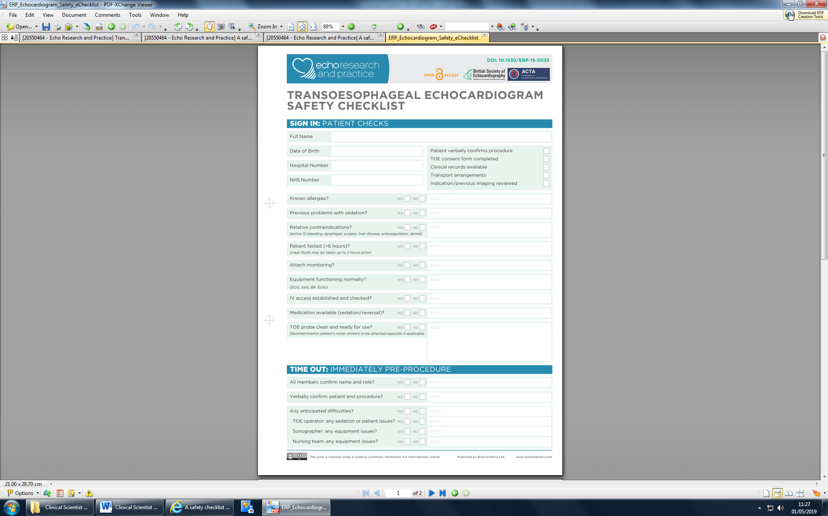
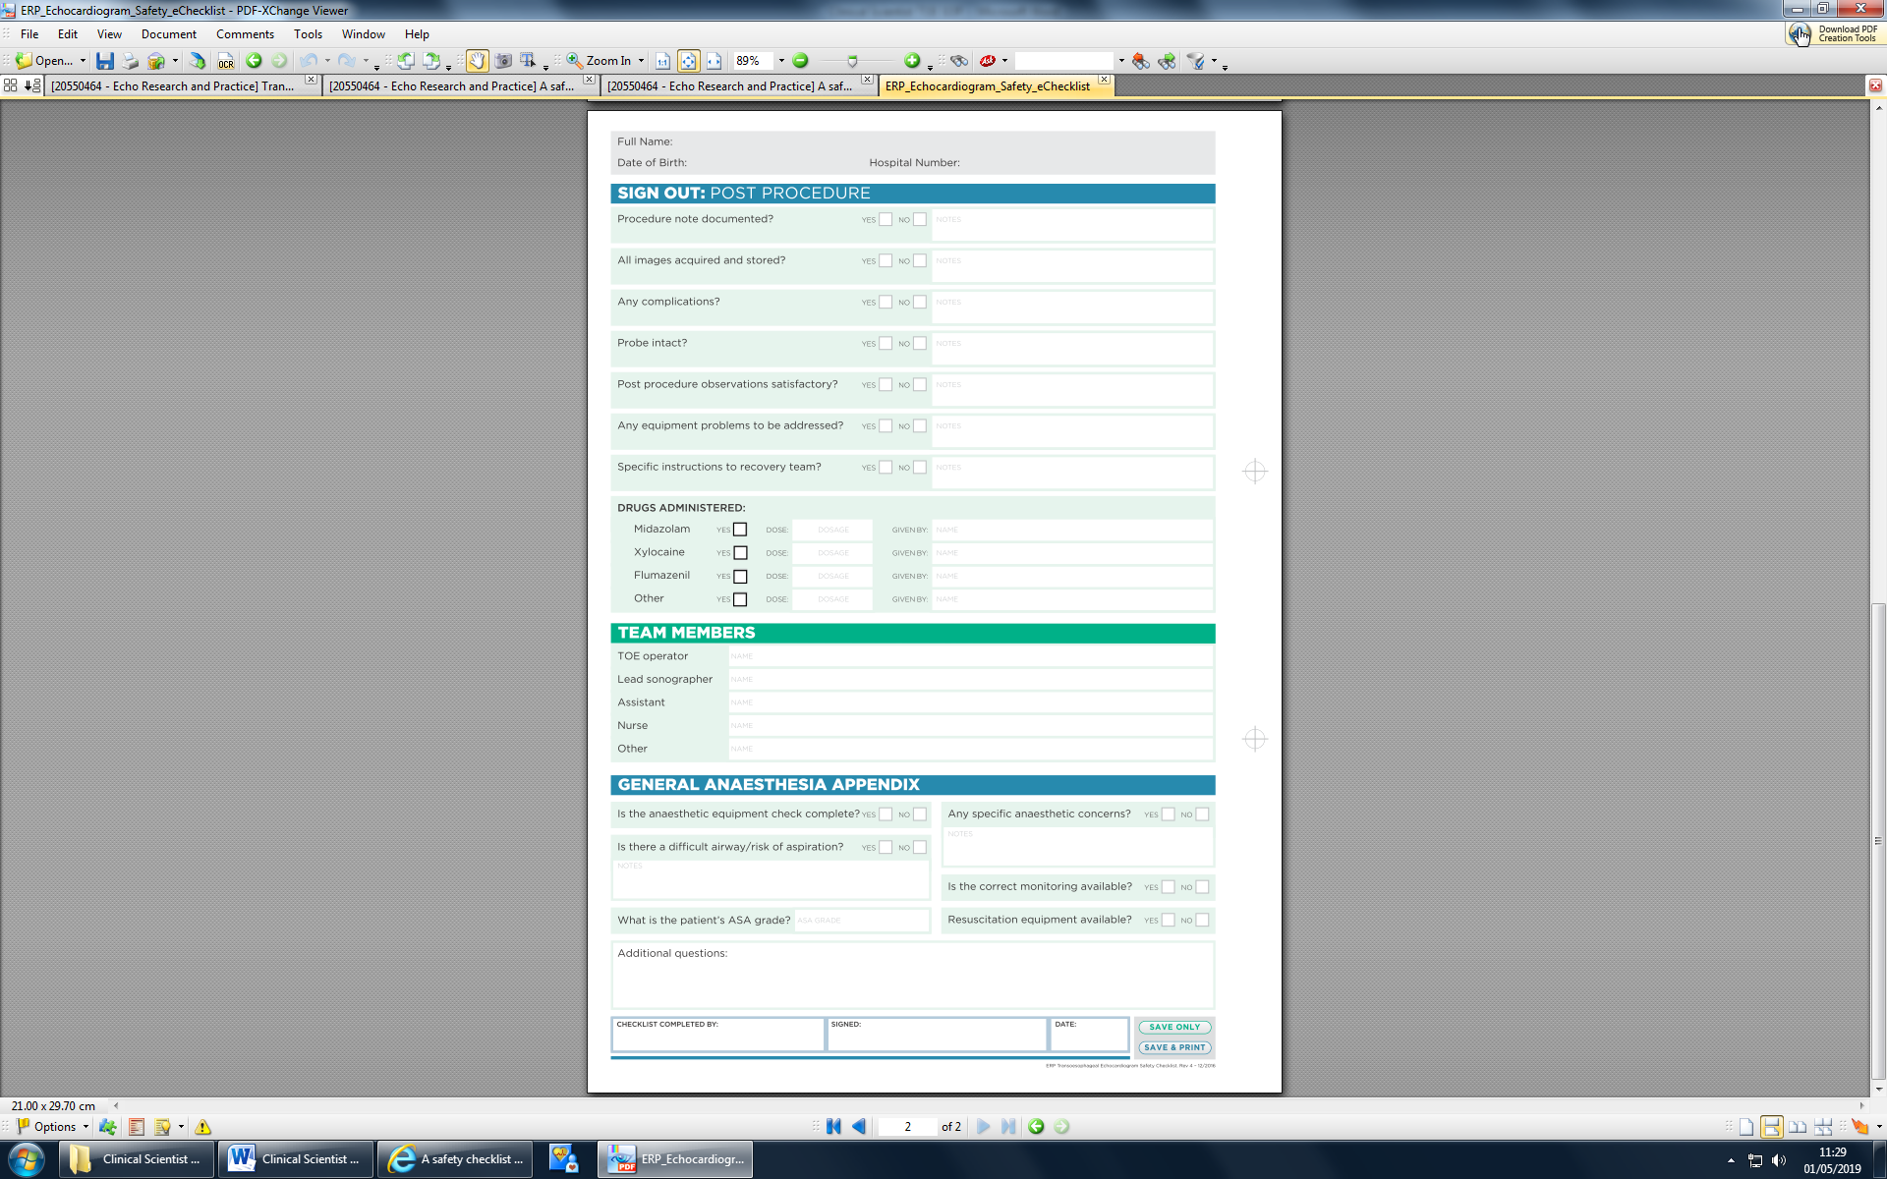

Appendix 2 – Trainee intubation logbook

Date | Patient’s hospital number | DOB | Reason for TOE | Sedation | Successful intubation? (Y/N) | Attempts | Consultant support (Y/N) | Complications

